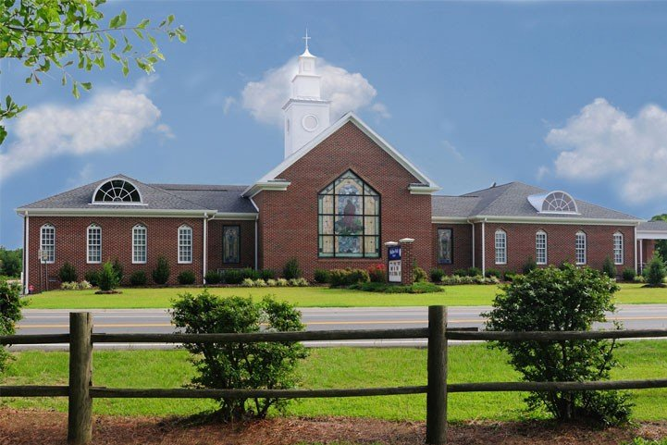
NEWS

FROM

THE

WELL

Shallow Well Church

1220 Broadway Road

Sanford, North Carolina 27332

Church Phone 919-776-1121

www.Shallow-Well.org Mary Griffin, Editor, (swcsecretary@minister.com)
Published Monthly February 2023

Making A Difference In Our World In Christ’s Name

Operation Christmas Child

In February we will continue to pick up hats, scarves, and mittens and add toothbrushes and combs to the items needed for Operation Christmas Child. Thanks for your generosity in providing the items needed. Place them in the box in the Narthex.
Women of the Well

The Women of the Well will meet on Sunday, February 19 at 4:00 on in the Parlor. All ladies of the church are welcome to come and join them.
Youth

The Youth will be very busy in February. They will be going to Teen Valley Ranch on February 3-5. Please keep them in your prayers for safe travels, deepening their faith, and safety skiing and snowboarding. They will help with the Souper Bowl on February 12. They will meet on February 19 and 26. They will also be going to Winter Jam on February 25 in Greensboro.

Souper Bowl of Caring

The Souper Bowl of Caring will be on Sunday, February 12. We need people to make a pot of soup or bring a dessert or drink.. Donations will be taken, and all proceeds will go to the CUOC and Outreach Mission. You will have the option to eat in or take it home.

Scout Sunday

The Cub Scouts and Boy Scouts of Pack 953 and Troop 953 will worship with us on Sunday, February 19. All loose change will go to the Scouts that day.

February Ministry Assistants

CUOC: Toboggans, scarves, mittens, stuffed animals, toothbrushes, and combs.
Deacon on Call: Feb. 5: Judy Watson; Feb. 12: John Godfrey; Feb. 19: Dawn Morris; Feb. 26: David Jordan.
Flowers: Feb. 5: LaVerne Maddox; Feb. 12: Mary Griffin; Feb. 19: open; Feb. 26: open.
Trustee to lock/unlock: Allen McKenzie

February Birthdays

04 Lynn Lemons
04 Lucas Rosser
10 Lily Currin
- A.K. Griffin
- Eddie Thomas
- Donna Buchanan
13 Robert Thomas
15 Dwayne Watson
16 Beryl Campbell
16 Nick Batchelor
17 Randy Gunter
- Joy Murphy
18 Mary John Coggins
18 Renee’ Ehlers
19 Glenda Douglas
21 Jada Holifield
24 Gary Watson
25 Kristi Collins
28 Debbie Scott
28 Lisa Matthews
28 Carolyn MacDonald

New Pew Cushions

We are replacing the seat cushions in the sanctuary. The new cushions will provide added comfort and enhance the beauty of our sanctuary. We are asking for your help with the cost of this project. One pew will cost approximately $300, and we have 47 pews. Please consider a donation, maybe even "adopting" your favorite pew to cover the cost. Whatever you are able to give is needed and appreciated. If you have any questions, please contact Sammy Poe. Thank you for your faithful giving and God bless you.

Bible Readings for February

Feb 1: Ex 27-28; Matt 21:1-22
Feb 2: Ex 29-30; Matt 21:23-46
Feb 3: Ex 31-33; Matt 22: 1-22
Feb 4: Ex 34-35; Matt 22:23-46
Feb 5: Ex 36-38; Matt 23:1-22
Feb 6: Ex 39-40; Matt 23:23-39
Feb 7: Lev 1-3; Matt 24:1-28
Feb 8: Lev 4-5; Matt 24:29-51
Feb 9: Lev 6-7; Matt 25:1-30
Feb 10: Lev 8-10; Matt 25:31-46
Feb 11: Lev 11-12; Matt 26:1-25
Feb 12: Lev 13; Matt 26:26-50
Feb 13: Lev 14; Matt 26:51-75
Feb 14: Lev 15-16; Matt 27:1-26
Feb 15: Lev 17-18; Matt 27:27-50
Feb 16: Lev 19-20; Matt 27:51-66
Feb 17: Lev 21-22; Matt 28
Feb 18: Lev 23-24; Mark 1:1-22
Feb 19: Lev 25; Mark 1:23-45
Feb 20: Lev 26-27; Mark 2
Feb 21: Num 1-2; Mark 3:1-19
Feb 22: Num 3-4; Mark 3:20-35
Feb 23: Num 5-6; Mark 4:1-20
Feb 24: Num 7-8; Mark 4:21-41
Feb 25: Num 9-11; Mark 5:1-20
Feb 26: Num 12-14; Mark 5:21-43
Feb 27: Num 15-16; Mark 6:1-29
Feb 28/29: Num 17-19; Mark 6:30-56
Baby Shower

There will be a baby shower for Kacie Harrison Bell on February 19 from 2:00-3:30 in the Fellowship Hall. It is a boy, and she is listed on Babylist.com.

Shallow Well Church
1220 Broadway Road
Sanford, North Carolina 27332
Dr. Eric Burmahl, Minister

Greetings, Shallow Well Church,

You may know that the national divorce rate is over 50 percent. You may not know that that same percentage applies to Christians. We take courses and receive training to improve our vocations, but have you ever considered investing in your marriage through training?

I want to offer you an opportunity for a Marriage Care seminar. To plan and proceed, I need to know if there is interest in our congregation. This would be open to guests as well. Please get in touch with me by text, email, or phone call if this is something that would interest you. Based on the response, I will publish more detailed information.

Thank you for your continued love and support; Sharon and I are blessed to serve you.

God bless you,

February 2023
Sun | Mon | Tue | Wed | Thu | Fri | Sat
 |  |  | 1 | 2 | 3 | 4
 |  |  | 7:00 Boy Scouts | Groundhog Day | Teen Valley Ranch | Teen Valley Ranch
5 | 6 | 7 | 8 | 9 | 10 | 11
Teen Valley Ranch | 7:00 Cub Scouts |  | 7:00 Boy Scouts
12 | 13 | 14 | 15 | 16 | 17 | 18
Lincoln's Birthday  Souper Bowl Sunday – bring a pot of soup or dessert. | 7:00 Cub Scouts | Valentine's Day | 7:00 Boy Scouts
19 | 20 | 21 | 22 | 23 | 24 | 25
Scout Sunday  2:00-3:30 Baby Shower for Kacie Bell  4:00 Women of the Well  Youth | President's Day |  | Washington's Birthday  7:00 Boy Scouts |  |  | Winter Jam in Greensboro
26 | 27 | 28
Youth | 7:00 Cub Scouts
Shallow Well Church

ring. Warm weather. Rebirth. Life begins anew. Easter . As the earth greens we feel hopeful and encouraged (and maybe a bit allergic)! In an effort to help you experience spiritual and personal rebirth this spring come into our library. There are many selections here to help raise your awareness. We highlighted these:
ADULTS:
Good News is for Sharing says it all. We Christians have both the responsibility and the privilege of passing on the good news.
HE CHOSE the NAILS challenges us and helps us to examine and receive all the gifts of the cross.
My Heart’s Cry exposes us to the influence Jesus had on his disciplines and he want to have…on us.
TEENS/PRETEENS:
WALKING THE BIBLE eloquently guides you on a journey that retraces the greatest Bible stories ever told.
CHILDREN:
Why Is There A Cross? answers the biggest question a child will ever need answered.
An Easter Alleluia lets children sing, learn, and share the story of Jesus’ resurrection.

