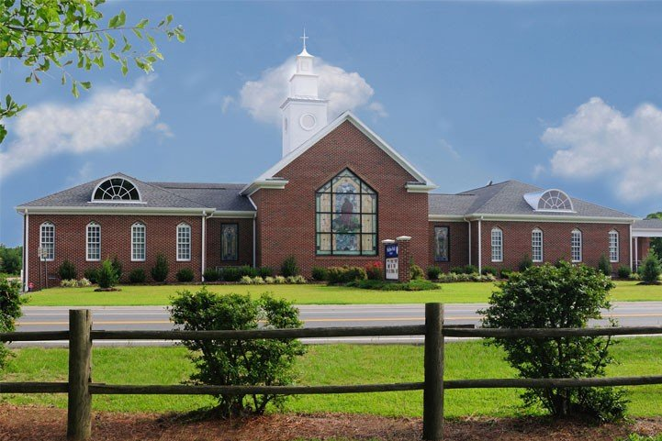
NEWS

FROM

THE

WELL

Shallow Well Church

1220 Broadway Road

Sanford, North Carolina 27332

Church Phone 919-776-1121

www.Shallow-Well.org Mary Griffin, Editor, (swcsecretary@minister.com)
Published Monthly May 2023

Making A Difference In Our World In Christ’s Name

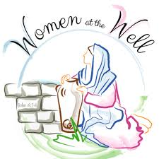
Women of the Well

The Women of the Well will meet on Sunday, May 21 at 4:00 on in the Parlor. All ladies of the church are welcome to come and join them.

Operation Christmas Child

In May, the items for Operation Christmas Child are yoyo, jump ropes, marbles, card games, and flashlight. Thanks for your generosity in providing the items needed. Place them in the box in the Narthex.
Mother’s Day

Mother’s Day is May 8, and we will honor all mothers during our morning Worship Service with a special gift. We will also honor our oldest mother present our youngest mother present and the “newest” mother present. We hope you will plan to be present in worship for this special day.
Teacher Appreciation

We will honor all teachers on Sunday, May 21. After Worship there will be a catered meal in the Fellowship Hall. We are inviting all teachers and their families to come and be with us. Please make sure to personally invite your child’s teacher (s). We will be sending out letters of invitation to the schools.
Looking Ahead

We will have our annual Homecoming and Memorial Day observance on Sunday, June 4th. During this service we will remember those who have passed from this life during the past year and welcome past members back for the day. There will be a covered dish lunch in the Fellowship Hall following worship, so plan to come with a well filled basket of food.

High School Graduates

We will honor our High School and College graduates on June 11 during the Worship Service. Hope you will be present for this special day. Our High School graduates are Jackson Godfrey and McKenzie Baldwin, and our College graduate is Cortney Maness. If we have missed anyone, please let us know.

Deacons Meeting

There will be a Board of Deacons meeting on Tuesday, May 23 at 7:00 in the Library. All Deacons should plan to attend.
May Ministry Assistants

CUOC: Canned beans/Pork and beans
Deacon on Call: May 7: Alan Coc; May 14: Barbara Norris; May 21: Earl Murphy; May 28: Brittany Griffin.
Flowers: May 7: open; May 14: Linda Barber; Mary 21: Wilma Truelove; May 21: open.
Trustee to lock/unlock: Randy Gunter

Birthdays for May

02 Sam Taylor
02 Aubrey Bond
03 Mark Jones
03 Candis Adcock
05 Jan Wilson
06 Oneda Dickens
06 John Haas
09 Kristie Gutierrez
- Darnell Miller
11 Beth Haas
12 Kelli Jones
12 Lora Currin
14 Gracie Currin
14 Ava Baldwin
14 Elyse Baldwin
15 Larry Thomas
16 Jennifer Watson
18 Mae Spivey
18 Alex McKenzie
19 Jensen Gunter
19 Drew Walker
21 Jackson Godfrey
- Camellia Hempe
25 Lee Chaiken
26 Jackie Thomas
28 Linda Holder
31 Savannah Godfrey
Scholarship

It is time to fill out applications for the O’Connell, Cox, McNeill scholarship. Applications are available on the website. The deadline to turn them in is June 1. If you have any questions, please contact Brittany Griffin.

Bible Readings for May

May 1: 1 King 10-11; Luke 21:20-38
May 2: 1 King 12-13; Luke 22:1-30
May 3: 1 King 14-15; Luke 22:31-46
May 4: 1 King 16-18; Luke 22:47-71
May 5: 1 King 19-20; Luke 23:1-25
May 6: 1 King 21-22; Luke 23:26-56
May 7: 2 King 1-3; Luke 24:1-35
May 8: 2 King 4-6; Luke 24:36-53
May 9: 2 King 7-9; John 1:1-28
May 10: 2 King 10-12; John 1:29-51
May 11: 2 King 13-14; John 2
May 12: 2 King 15-16; John 3:1-18
May 13: 2 King 17-18; John 3:19-36
May 14: 2 King 19-21; John 4:1-30
May 15: 2 King 22-23; John 4:31-54
May 16: 2 King 24-25; John 5:1-24
May 17: 1 Chron 1-3; John 5:25-47
May 18: 1 Chron 4-6; John 6:1-21
May 19: 1 Chron 7-9; John 6:22-44
May 20: 1 Chron 10-12; John 6:45-71
May 21: 1 Chron 13-15; John 7:1-27
May 22: 1 Chron 16-18; John 7:28-53
May 23: 1 Chron 19-21; John 8:1-27
May 24: 1 Chron 22-24; John 8:28-59
May 25: 1 Chron 25-27; John 9:1-23
May 26: 1 Chron 28-29; John 9:24-41
May 27: 2 Chron 1-3; John 10:1-23
May 28: 2 Chron 4-6; John 10:24-42
May 29: 2 Chron 7-9; John 11:1-29
May 30: 2 Chron 10-12; John 11:30-57
May 31: 2 Chron 13-14; John 12:1-26
Missions Giving
When I designate a gift to Missions in my offering where do the funds go? Missions offering collected during the year go into the Missions Fund. At the end of the year the balance in the Missions Fund is designated to various organizations by the Deacon Board. This would be general Missions giving not specific love offerings taken up throughout the year which are announced as special offerings to various organizations and distributed at the time taken. On behalf of the Missions Committee, thank you for being a Mission focused church, helping those in need in the name of Jesus Christ.

Shallow Well Church
1220 Broadway Road
Sanford, North Carolina 27332
Dr. Eric Burmahl, Minister

Greetings Church Family,

We have an excellent opportunity to bless our local teachers by inviting them and their families to our Teacher Appreciation Sunday on May 21, 2023.
At 10:55 am, we will have an exceptional worship service to honor our Shallow Well teachers and guest teachers. Our teachers need encouragement and uplifting in these current times. I know Shallow Well will be a blessing to these extraordinary educators.
Immediately following the service, we will provide a catered meal in our Fellowship Hall. I ask for your help with this endeavor in the following ways, please:
First, we need (several) desserts (because Shallow Well's desserts are the best) for lunch.
Second, we need volunteers to help with the meal and to greet our guests.
Third, please invite teachers you know and their families. This is a great way to connect them to Shallow Well Church and show our appreciation for their service.
Fourth and most important, please pray for this opportunity. Pray for those who are unchurched to come. Pray also that doors will be opened to invest in the lives of our guests and their families.
Finally, pray that we glorify the Lord Jesus Christ through our efforts.
Sharon and I are very grateful for your love and support!
God bless you,

Eric Burmahl

May 2023
Shallow Well Church
Sunday | Monday | Tuesday | Wednesday | Thursday | Friday | Saturday
 | 1  7:00 Cub Scouts | 2  10:00 Learn and Lunch | 3  7:00 Bible Study  7:00 Boy Scouts | 4 | 5 | 6
7  4:00 Youth | 8  7:00 Cub Scouts | 9  10:00 Learn and Lunch | 3  7:00 Bible Study  7:00 Boy Scouts | 11 | 12 | 13
14  Mother’s Day  10:55 Honoring our Mother’s | 15  7:00 Cub Scouts | 16  10:00 Learn and Lunch | 3  7:00 Bible Study  7:00 Boy Scouts | 18 | 19 | 20  Youth Outing – More to come later
21  10:55 Teacher’s Appreciation  4:00 Women of the Well  4:00 Youth | 22  7:00 Cub Scouts | 23  10:00 Learn and Lunch  7:00 Deacons’ meeting | 3  7:00 Bible Study  7:00 Boy Scouts | 25 | 26 | 27
28 | 29  Memorial Day | 30  10:00 Learn and Lunch | 3  7:00 Bible Study  7:00 Boy Scouts

ring. Warm weather. Rebirth. Life begins anew. Easter . As the earth greens we feel hopeful and encouraged (and maybe a bit allergic)! In an effort to help you experience spiritual and personal rebirth this spring come into our library. There are many selections here to help raise your awareness. We highlighted these:
ADULTS:
Good News is for Sharing says it all. We Christians have both the responsibility and the privilege of passing on the good news.
HE CHOSE the NAILS challenges us and helps us to examine and receive all the gifts of the cross.
My Heart’s Cry exposes us to the influence Jesus had on his disciplines and he want to have…on us.
TEENS/PRETEENS:
WALKING THE BIBLE eloquently guides you on a journey that retraces the greatest Bible stories ever told.
CHILDREN:
Why Is There A Cross? answers the biggest question a child will ever need answered.
An Easter Alleluia lets children sing, learn, and share the story of Jesus’ resurrection.

